W368R-How to prevent others to connect to my wireless network?
Product line: Wireless Question category: Function configurations

Q: What do we use Access Control?
A: Wireless access control is actually based on the MAC address to permit or forbid specific clients accessing the wireless network. You can achieve this through setting wireless Access Control.

The Topology is as below:

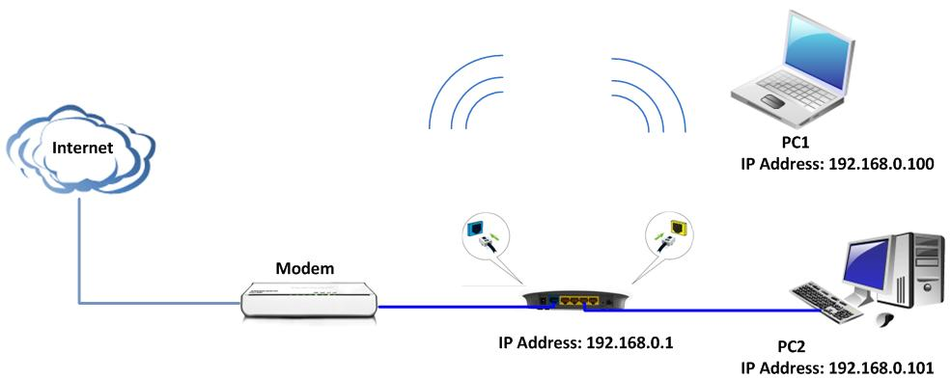

The Steps are as below:
1. Connect the computer to the router’s yellow LAN port with an Ethernet cable and login to the router’s home page.
2. After successfully login to the router’s home page, click on the Advanced Settings in the top right. Then in the main menu on the top, please select Wireless settings → Access Control. There are three options (Disable, Forbid, and Permit). The Access Control is disabled in default.

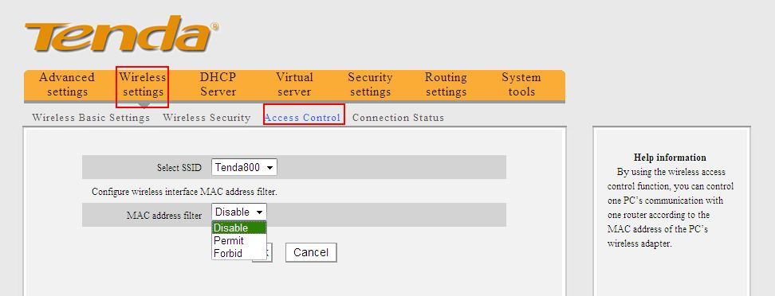

Forbid: If you want to let a specific computer or some computers not access your wireless network (as shown in the following topology), please choose Forbid after the Mac address filter, and then input the MAC address of that computer(00:01:01:01:01:01) and click on Add. Then click on OK to apply it. So PC with mac address 00:01:01:01:01:01 can’t access this wireless network.

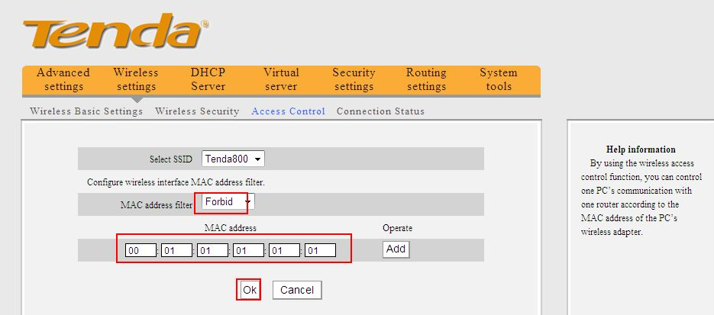

Permit: If you only want a specific computer or some computers to access your wireless network, please choose Permit after the Mac address filter, and then input the MAC address of that computer(00:02:02:02:02:02) and click on Add. Then click on OK to apply it. So only the computer with mac address 00:02:02:02:02:02 can connect to the wireless network.

